Least Laxity First (LLF)
# Source: AI Source: Provided by: [Data Path: Persons Table -> ID Column: 1, Name_En Column: Motasem Essam] -> From: [ChatGPT] on [1/21/2026]
Least Laxity First (LLF) is a dynamic scheduling algorithm used in Real-Time Systems (RTS) that focuses on the urgency of tasks relative to their deadlines. It is less common than EDF but very useful for systems where minimizing deadline misses is critical.

Definition
# Source: AI Source: Provided by: [Data Path: Persons Table -> ID Column: 1, Name_En Column: Motasem Essam] -> From: [ChatGPT] on [1/21/2026]
LLF schedules tasks based on their laxity (also called slack time), which is defined as:
[
\text{Laxity} = \text{Time until deadline} - \text{Remaining execution time}
]
- Task with the smallest laxity is scheduled first.
- Priorities can change dynamically as deadlines approach or remaining execution time decreases.

Key Features
# Source: AI Source: Provided by: [Data Path: Persons Table -> ID Column: 1, Name_En Column: Motasem Essam] -> From: [ChatGPT] on [1/21/2026]
- Dynamic Priority: Laxity values are computed at runtime, so priorities are continuously updated.
- Deadline-Oriented: Tasks closest to missing their deadlines get highest priority.
- Preemptive: A task with less laxity can preempt a currently running task.
- Optimal for Minimizing Deadline Misses: If a schedule exists that meets all deadlines, LLF can find it.

Advantages
# Source: AI Source: Provided by: [Data Path: Persons Table -> ID Column: 1, Name_En Column: Motasem Essam] -> From: [ChatGPT] on [1/21/2026]
- Highly Deadline-Sensitive: Prioritizes tasks most at risk of missing deadlines.
- Optimal for Certain Systems: Can schedule periodic and aperiodic tasks with maximum feasibility.
- Reduces Missed Deadlines: Minimizes the chance of late task completion.

Disadvantages
# Source: AI Source: Provided by: [Data Path: Persons Table -> ID Column: 1, Name_En Column: Motasem Essam] -> From: [ChatGPT] on [1/21/2026]
- High Runtime Overhead: Laxity must be recalculated frequently.
- Frequent Preemptions: Can cause more context switching, increasing CPU load.
- Complex Implementation: Harder to implement than RMS or EDF.

Example
# Source: AI Source: Provided by: [Data Path: Persons Table -> ID Column: 1, Name_En Column: Motasem Essam] -> From: [ChatGPT] on [1/21/2026]
Suppose we have three tasks at time t = 0:
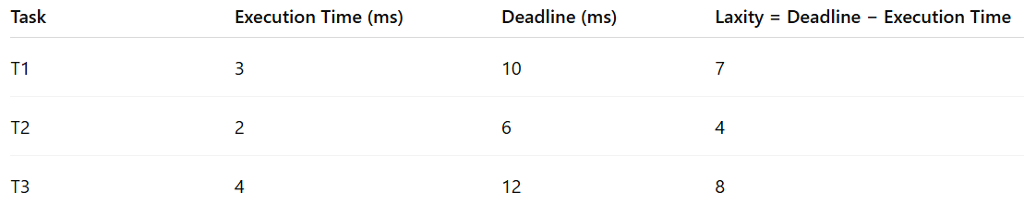
Task | Execution Time (ms) | Deadline (ms) | Laxity = Deadline − Execution Time
T1 | 3 | 10 | 7
T2 | 2 | 6 | 4
T3 | 4 | 12 | 8
- LLF Scheduling Order: T2 → T1 → T3
- Task T2 has the least laxity (4 ms) → executed first
- Priorities may change dynamically if remaining execution time changes or new tasks arrive.

Why LLF Matters for Software Engineers
# Source: AI Source: Provided by: [Data Path: Persons Table -> ID Column: 1, Name_En Column: Motasem Essam] -> From: [ChatGPT] on [1/21/2026]
- Useful in critical real-time systems where missing deadlines is unacceptable.
- Teaches laxity-based priority computation and dynamic scheduling concepts.
- Helps design systems with tight timing constraints, like aerospace, medical devices, or advanced robotics.

